CONDITIONAL SENTENCES

1. Choose the correct form

1. I worked / would work in London if I had / would have the chance.
2. I’m really sorry. I would tell / would have told you earlier if I had / had had the chance, but I’ve been busy all day.
3. If I am / were CEO I will / would give everyone a raise.
4. If I were / had been in charge of the last project I would delegate / would have delegated a little more than the project manager did.
5. She seems a bit reluctant to do the presentation. Perhaps if we gave / had given her some help with the slides, she would accept / would have accepted.
6. It was / would have been better if I had / would have never met him.
7. I helped / would help you if I had / would have the time.
8. We ran out of time at the meeting. If we had / had had more time, we would cover / would have covered all the items on the agenda.

Wallwork, A. (2018): Top 50 Grammar Mistakes

2.
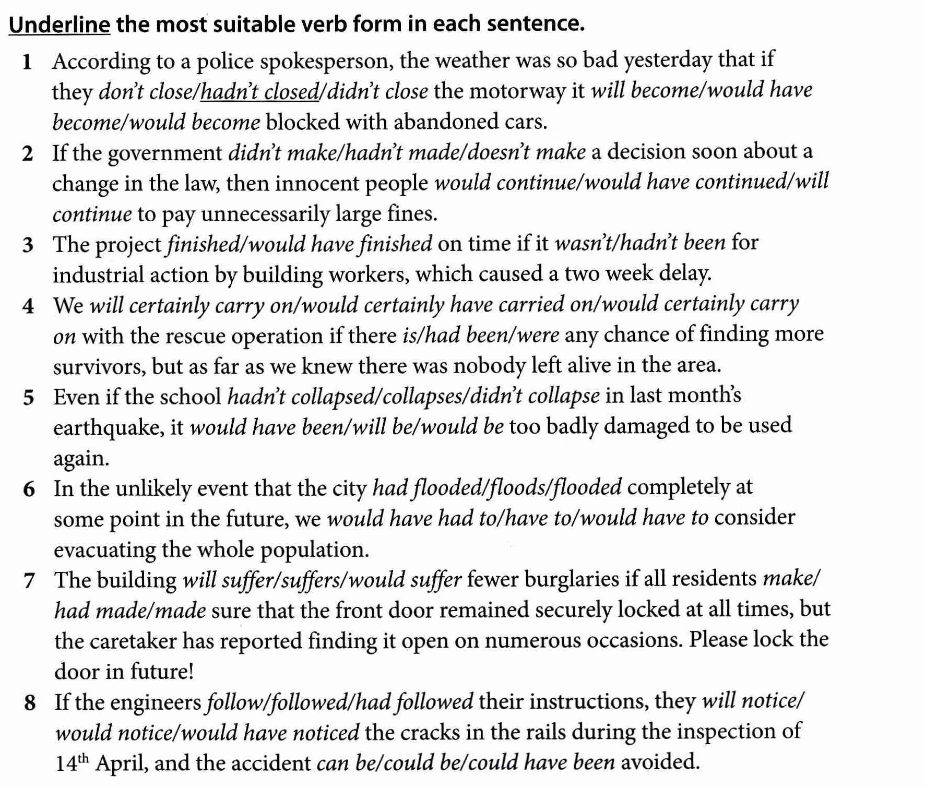

IELTS Language Practice
3. Fill the gaps with suitable words.

Dear Sir or Madam,

We would like to remind you that your account is two months overdue. We are prepared to allow you another ten days to settle your account. However, (1)............. you fail to pay your outstanding bills within ten days, you leave us with no alternative but to take legal action. That is, (2) ................we receive full payment by 20th March, we will refer this matter to our legal department. If (3) ................, we are prepared to make a claim in the Small Claims court for the money owed plus interest.

(4) ................you be experiencing financial difficulties, please contact our Finance Department. (5) ................that you settle your account within the specified time period, we will (6) ................happy to continue to do business with you. However, we (7) ................, if necessary, take the regrettable step of closing your account.

We are sorry that this situation has arisen, but if you had paid your bills over the last two months, we (8) ................not be in this position now. On the other hand, you (9 ) ................have settled your account in the last two days. If (10)................. , please accept our apologies for this letter.

Yours faithfully

Brian Eccles

Customer Services
Wood View Office Supplies

IELTS Language Practice

